*SCATS Application*

installation and maintenance

Version *1.0*

*01/19/2020*

Contents

Installation 3

Download the latest JAR file 3

Unzipping the Archive 4

Authentication 4

Troubleshooting 4

## Installation

### Download the latest JAR file

Version 1.0 of the Security Consultant Assignment/Engagement Tracking System (SCATS) can be downloaded from the [Cygiene Solutions](http://cygienesolutions.com/scats.html) website.

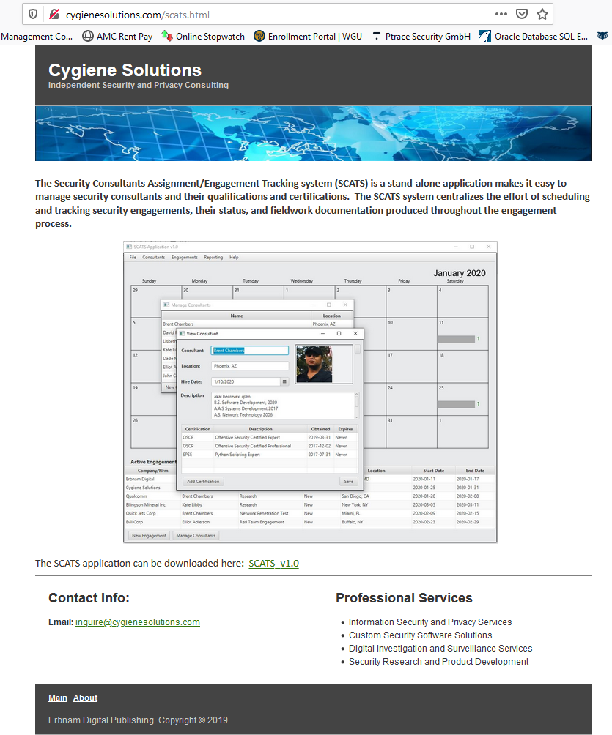

Direct download link: <http://cygienesolutions.com/scats/SCATSv1.zip>

### Unzipping the Archive

Once the download completes, unzip the ZIP file in a desired location on your file system. Once unzipped, double click on the SCATSApplication.jar file to launch the program.

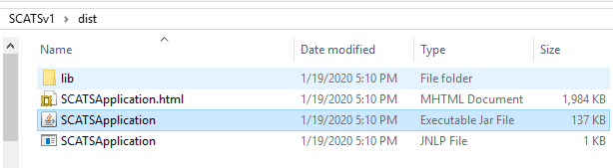

### Authentication

You will be asked for credentials upon executing the application. The default credentials for the application are *admin:admin.*

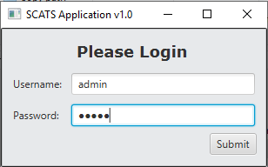

## Troubleshooting

If the SCATS Application cannot authenticate and won’t launch, check your network connection settings to ensure you have access to the Internet.